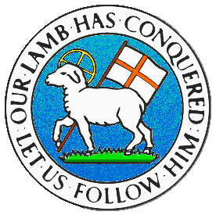
CHILDREN BROCHURE

MORAVIAN CHURCH – BARBADOS CONFERENCE
Provincial Theme: Advance the Kingdom: S.H.I.F.T.

S. – Seek & Submit
H. – Hear & Heed
I. – Imagine & Insight
F. – Focus & Function
T. – Totally Transformed

Age: 8 – 12 yrs.
S.H.I.F.T.

December 12

Scripture:

Proverbs 1:23 Turn at my rebuke. Surely I will pour out my spirit on you; I will make my words known to you. (NKJV)

Message:

It is not good enough to be moving around blindly in this world as it is today. We need to be focused and have a vision as to where we are going and what we need to do. Some of us are involved in some serious wrong doing and do not want anyone to chastise or correct us. When persons speak to us, we become miserable and agitated, behaving in an ignorant manner. No one should want to live in a state of sin which would short change their growth and development in Jesus Christ. Our word today says we must first of all accept the rebuke of the Lord and to turn back to Him.

We note when we turn back to Jesus, it is when we will receive the many blessings He has promised to us. One of the blessings is when we have emptied ourselves of sin, He then pours into us His holy Spirit to fill us and shape us into what He wants. In pouring His Spirit into us, we then will be able to concentrate on the direction in which we must go. He also fills us with His word, which gives us knowledge and understanding to stand up against what is wrong and to also speak as well as act as a child of God.

Activity:

Fit one of the words into the spaces below.

Words speak God Lord
Child Live pour correction
Accept act Spirit making

S _ _ _ _ as a c _ _ _ _ of G _ _;
A _ _ as a c _ _ _ _ of G _ _;
L _ _ _ as a c _ _ _ _ of G _ _.

A _ _ _ _ _ the c _ _ _ _ _ _ _ _ _ of the L_ _ _ _;
And He will p _ _ _ His S _ _ _ _ _ into you;
M _ _ _ _ _ His w _ _ _ _ known to you.

(Answers next week)

(Answer from last week)

A good name is better than fine perfume.

Ecclesiastes 7:1

