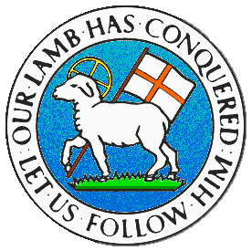
CHILDREN BROCHURE

MORAVIAN CHURCH – BARBADOS CONFERENCE
Provincial Theme: Advance the Kingdom: S.H.I.F.T.

S. – Seek & Submit
H. – Hear & Heed
I. – Imagine & Insight
F. – Focus & Function
T. – Totally Transformed

Age: 7 yrs. & Under
S.H.I.F.T.

February 14

Scripture:

Galatians 6:2 Carry one another’s heavy loads. If you do, you will fulfill the law of Christ. (NIRV)

Message:

If you and your brother were walking down the street and he fell down, would you continue walking and leave him there, or stop and help him to get up, making sure that he was not hurt? Or, if your sister was carrying some groceries and the bag burst, spilling the food all over the pavement. Would you help her to pick them up or leave her to sort it out by herself? When we see our friends in difficulties and we can help them to make things better, we should do the best we can to help them.

We ought not to be selfish or mean, but help others especially if we can do something about it. We can even turn it around. If we are in trouble and need some help, we would love to have someone give us a helping hand. No one likes to be in trouble especially if it happens suddenly, only to find ourselves alone and with no one to rescue us. When we help others we are doing what Jesus would do and that makes us special. So when you can help, go ahead and make things better.

Activity: Replace the symbols with the correct letter:

A | E | I | O | U

HELP OTHERS!

A | B
H | HW
E | VRYBDY
L | LV
P | PRSNS
s t
O | BY
T | TH
H | HLY
E | (EDICT) LW (nd)
R | (REALIZE) GT
S | (SATISFACTION WITH) JSS

Using the words with symbols, write out the sentence from column B:
___________________________________________________

(Answer next week)

(Answers from last week)

Things that are Important | Things that may not last
Love | Kite
Peace | New Clothes
Truth | Bicycle
Joy | Nice Shoes
Kindness

