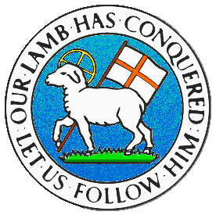
CHILDREN BROCHURE

MORAVIAN CHURCH – BARBADOS CONFERENCE
Provincial Theme: Advance the Kingdom: S.H.I.F.T.

S. – Seek & Submit
H. – Hear & Heed
I. – Imagine & Insight
F. – Focus & Function
T. – Totally Transformed

Age: 7 yrs. & Under
S.H.I.F.T.
July 25

Scripture:

Luke 9:62 Jesus said to him, “Anyone who starts to plow and then keeps looking back is of no use for the Kingdom of God.” (GNT)

Message:

When someone asks you to do something and you say you will do it, then do it. Do not say you will do it and change your mind as you get half the way. As you say yes to doing a thing, the person is depending on you to keep your word and to see it to the end. Can you imagine how disappointed the person feels when you give it up, with no good reason and leave things in a mess? If you know you cannot do it, then do not say yes in the first place. Sometimes things happen which may cause you to change your mind, and in that case, give an explanation.

It goes deeper when you have a change of heart and you are now serving the Lord Jesus Christ. As you serve Him and live for Him, do not look back to the life you used to live. That was the old life, the old and sinful way of doing things. If you keep looking back and not pay attention to what Jesus has in store for you, you will lose out on the goodness of God. As you live for God, focus on Him so that you will stay in tune with what He has for you, as well as where He wants you to go and to do.

Activity:

Write YES or NO at the end of the following sentences:

- The old and sinful life is the better life. _______
- It is better to give my heart to the Lord. _______
- The new life with Jesus is the better life. _______
- Jesus has a better plan for me than the old way of life. ______
- When I serve Jesus I must leave the old life behind. ______

(Answers from last week)

- GOD IS GREAT
- GOD IS GOOD
- GOD IS LOVE
- GOD IS HOLY
- GOD IS JOY
- GOD IS PEACE

