CHILDREN BROCHURE

MORAVIAN CHURCH – BARBADOS CONFERENCE
Provincial Theme: Advance the Kingdom: S.H.I.F.T.

S. – Seek & Submit
H. – Hear & Heed
I. – Imagine & Insight
F. – Focus & Function
T. – Totally Transformed

S.H.I.F.T.

Age: 13 yrs. & Over

May 16

Sing with me

https://www.youtube.com/watch?v=iQMpLjXJ3Cc

I sought the Lord (Arr. Karen Smith)

Memory verse: Psalms 34: 4 NRSV

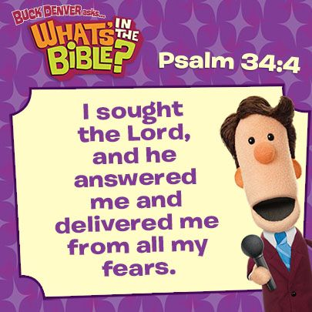
Scripture: Psalm 34:1 – 10 NRSV
Read with me.
1I will bless the Lord at all times;
his praise shall continually be in my mouth.
2 My soul makes its boast in the Lord;
let the humble hear and be glad.
3 O magnify the Lord with me,
and let us exalt his name together.
4 I sought the Lord, and he answered me,
and delivered me from all my fears.
5 Look to him, and be radiant;
so your[a] faces shall never be ashamed.
6 This poor soul cried, and was heard by the Lord,
and was saved from every trouble.
7 The angel of the Lord encamps
around those who fear him, and delivers them.
8 O taste and see that the Lord is good;
happy are those who take refuge in him.
9 O fear the Lord, you his holy ones,
for those who fear him have no want.
10 The young lions suffer want and hunger,
but those who seek the Lord lack no good thing.
Let us talk about it
Remember last week we talked about David’s continual praise of God. David was so pleased with the guidance and protection he received from God, that he continued to praise God. This week David is going further in justifying his praise to God.
For some reason, David seemed to be always in trouble. David tells us in verse 4 how he sought the Lord. So, what does it mean to seek God? Seeking God is a conscious effort to set our minds towards Him in our experiences and to direct our minds and hearts to God.
Remember, we talked about the heart, not the physical heart, but the spiritual heart which controls our mind and our thoughts. David was able to testify that the Lord heard and answered him and delivered him from his fears. David developed such a closeness to the Lord, he blessed the Lord at all times, and continually sang songs of praise to God.
But how do we set out to seek the Lord? We seek the Lord through prayer. What are your greatest fears? We talked last week about some of our fears. Many of us find ourselves in trouble or we encounter some difficulty in life. What do we do? We go to our friends, or maybe our parents or teacher. Have you thought of going to God first? David is offering us a choice. This is what worked for him. Maybe it will work for you. David remembers as he encountered trouble, he sought the Lord. David says the Lord saved him. In Jeremiah, God makes this promise, “You will seek me and find me when you seek me with your whole heart.” (Jeremiah 29:13).
Not only will God hear us, but God will answer us. The Lord has promised if we seek him, we will find him., David is encouraging us to take our fears and concerns to the Lord, first. The process begins when we spend focused, intentional time with God. God will answer our prayers and deliver us from our worries, just as he did for David. God may not answer in our time, or when we think he should, but as we seek the Lord, through pray, God will be there for us. Yes, we need to go to God in prayer.
David acknowledged the Lord is close to those who are humble of heart, or poor in spirit, and who are ready and willing to seek the Lord at all times, even in times of distress and danger. Remember the beatitude, “Blessed are the poor in spirit for theirs is the kingdom of heaven.” Matthew 5:3. David had witnessed God's faithfulness on many occasions. His trust was in the Lord's deliverance, when his own, frail heart was fainting from fear of what was happening on the earth. When we seek God, He will answer. When God answers, we realize we are not alone.
Let us pray
Heavenly Father, You are worthy to be praised and I will bless You at all times and in all places. I will make my boast in the Lord, for I sought after You and You heard my cry and answered me. You have redeemed my life from the clutches of the evil one, and delivered me from all my fears. You have forgiven my sin and clothed me in Christ's own righteousness, for His name's sake - and You alone are worthy of my praise and thanksgiving forever and ever - AMEN.
More Easter facts
Thursday, 13th May, 2021
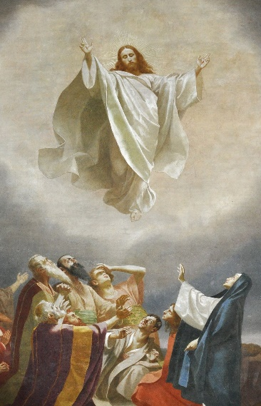
Ascension Day
Ascension Day is the day when Christians celebrate the ascension of Jesus Christ into heaven as recorded in the Bible. It is celebrated exactly 39 days after Easter Sunday and always falls on a Thursday. The Ascension of Jesus Christ is meaningful to Christians as it signifies the end of Jesus’ work on Earth and allowed Him to prepare a place for followers in heaven.

ACTIVITY

Activity 1:
Each number represents a letter in the alphabet, as shown.
Write the correct letter in each space below to find the coded words and complete the verse.
CODE KEY
A 1 | B 2 | C 3 | D 4 | E 5 | F 6 | G 7 | H 8 | I 9 | J 10
K 11 | L 12 | M 13 | N 14 | O 15 | P 16 | Q 17 | R 18 | S 19 | T 20
U 21 | V 22 | W 23 | X 24 | Y 25 | Z 26

$$\frac{}{9} \frac{}{19}\frac{}{15}\frac{}{21}\frac{}{7}\frac{}{8}\frac{}{20} \frac{}{20}\frac{}{8}\frac{}{5} \frac{}{12}\frac{}{15}\frac{}{18} \frac{}{4} \frac{}{1}\frac{}{14}\frac{}{4} \frac{}{8}\frac{}{5} \frac{}{1}\frac{}{14}\frac{}{19}\frac{}{23}\frac{}{5}\frac{}{18}\frac{}{5}\frac{}{4} \frac{}{13}\frac{}{5}$$

Activity 2: Word Challenge
Make 40 or more words from the letters in the word
INTENTIONAL
Ask a friend to join you. Who can make the most words?
11 letters | 9 letters | 8 letters | 7 letters | 6 letters | 5 letters | 4 letters | 3 letters | 2 letters

