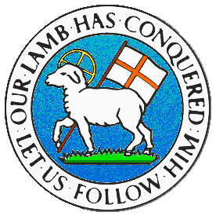
CHILDREN BROCHURE

MORAVIAN CHURCH – BARBADOS CONFERENCE
Provincial Theme: Advance the Kingdom: S.H.I.F.T.

S. – Seek & Submit
H. – Hear & Heed
I. – Imagine & Insight
F. – Focus & Function
T. – Totally Transformed

Age: 13+ yrs

SUBMIT

May 17 – Submit to Discipleship

Song:

There Were Twelve Disciples
There were twelve disciples Jesus called to help him:  Simon Peter, Andrew, James, his brother John,  Philip, Thomas, Matthew, James the son of Alphaeus,  Thaddeus, Simon, Judas, and Bartholomew. | He has called us, too. He has called us, too.  We are His disciples, I am one and you!  He has called us, too. He has called us, too.  We are His disciples, I am one and you!

Sing along:

https://www.youtube.com/watch?v=9JS1ZOQSj74

https://www.youtube.com/watch?v=KL7uV5jF8Rk

Memory Verse: Mark 1:17

“Come and follow me,” “I will send you out to fish for people.”

Scripture: (Read with me)
Mark1: 16 - 20 (NIRV)
Jesus Chooses His First Disciples
16 One day Jesus was walking beside the Sea of Galilee. There he saw Simon and his brother Andrew. They were throwing a net into the lake. They were fishermen. 17 “Come and follow me,” Jesus said. “I will send you out to fish for people.” ¹⁸ At once they left their nets and followed him.
19 Then Jesus walked a little farther. As he did, he saw James, the son of Zebedee, and his brother John. They were in a boat preparing their nets. 20 Right away he called out to them. They left their father Zebedee in the boat with the hired men. Then they followed Jesus.

Message:

When Jesus invited people to follow Him, He was asking them to become His disciples. In the simplest definition, a disciple is a follower of Jesus, disciples are those who follow Jesus when He calls them. Being a disciple means that you have chosen to trust Jesus and follow Him. Often people try to apply the teachings of Jesus—prayer, Bible reading, or His wise sayings—without first wanting to become one of His disciples. Submitting to becoming a disciple of Jesus is supported by God’s power as described by Paul in 1 Peter1:3 God’s power has given us everything we need to lead a godly life. All of this has come to us because we know the God who chose us. He chose us because of his own glory and goodness
You will need God’s power in order for you to become a good disciple. Discipleship relies on dependence and submission. To be a disciple of our Lord demands that He becomes the most important person in your life. Simply put, becoming a disciple means that you must love God more than anything or anyone else. God must come first. When you have to choose between following the world and following Jesus, it is always better to follow Jesus. This does not mean that you should neglect your family or friends. But if someone is asking you to do something that is against the teachings of the Lord, then you must choose God’s way. A disciple is one who shows he loves God by obeying His commands.

When you become a disciple of Jesus, you will get to know God’s power, you will be eager to follow God’s plan for your life, and you will allow God to take full control of your life. You choose to be on God’s team by accepting Jesus Christ. Not only that, but Jesus wants you to tell your friends about Him.

You see, God has a plan for your life. He promises to work all things together for good and give you the strength and energy to succeed if you are trusting and following Him. We might go through some tough times, but so did Jesus. And where is He now? Sitting on a throne next to God! So you can trust Him. You need to keep your focus on Him, and the plan God has for you will come to pass—because you are on God’s team!
Prayer for discipleship:

Lord Jesus Christ, you called us to follow You as disciples. Send us Your Holy Spirit to give us courage and wisdom to be faithful disciples. Help us to seek and find You in all that we do and may we do it with grateful hearts. This we pray in Jesus’ name. Amen

Activity 1.

These men followed Jesus

The names of the twelve disciples of Jesus are listed in the song at the beginning of this study. Or you can find them in the following passage.

Matthew 10:2 – 4

² Here are the names of the 12 apostles.
First there were Simon Peter and his brother Andrew.
Then came James, son of Zebedee, and his brother John.
3 Next were Philip and Bartholomew,
and also Thomas and Matthew the tax collector.
Two more were James, son of Alphaeus, and Thaddaeus.
4 The last were Simon the Zealot and Judas Iscariot. Judas was the one who was later going to hand Jesus over to his enemies.

Use these names to complete the first picture.

Activity 2:

Jesus chooses 12 disciples

Find the answers to questions 1 and 2 in puzzle 2.
To get the answer to question 1, begin at the top arrow (1), follow the diagram, and write the letters as you come to them, until there are no more letters. Put your letters into words to create the answer.
Then go to the second arrow (2) follow the diagram, and write the letters as you come to them, until there are no more letters. Write the letters to get the answer to question 2.
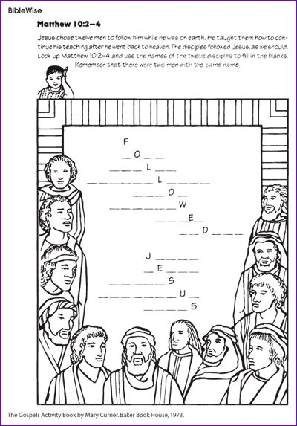
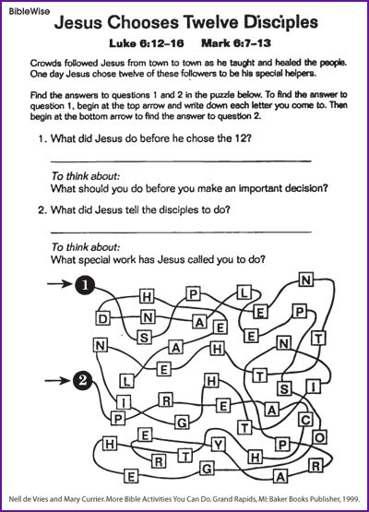

Mothers’ Day quizz (solutions)

Column A | Column B
 | Mother | Child (children)
1.She put her child in a specially made basket and put him in the river. | Jochebed (Numbers 26:59) | Moses
2.She did not understand how she could have a child when she was a virgin. | Mary (Luke 1:34) | Jesus
3.She helped her son to deceive his father by disguising himself as his twin brother. | Rebecca (Genesis 27: 5 – 10) | Jacob
4.She laughed when she was told that she would have a son. She was an old woman. | Sarah (Genesis 18:11 -13) | Isaac
5.She prayed for a son and promised that he would serve the Lord. | Hannah (1 Samuel 1: 10) | Samuel
6.Her son baptized Jesus. | Elizabeth ( Luke 1: 57 – 66) | John
7. She was the mother of two of Jesus’ disciples. | Salome (Matthew 20:20; Matthew 27: 56) | James and John
8.Her husband gave her son a coat of many colours. | Rachael (Genesis 35:24) | Joseph
9. She took her daughter-in-law back to the land of her birth. | Naomi (Ruth 1:3 -4; 19) | Ruth
10. She was the mother of Paul’s most trusted companion and disciple. | Unice (2 Timothy 1:5) | Timothy

