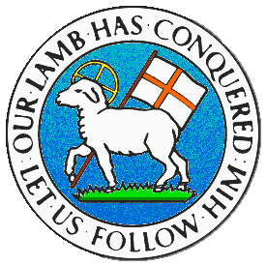
CHILDREN BROCHURE

MORAVIAN CHURCH – BARBADOS CONFERENCE
Provincial Theme: Advance the Kingdom: S.H.I.F.T.

S. – Seek & Submit
H. – Hear & Heed
I. – Imagine & Insight
F. – Focus & Function
T. – Totally Transformed

Age: 8 – 12 yrs.
S.H.I.F.T.
October 24

Scripture:

Romans 12:14 “Bless those who hurt you. Bless them, and do not curse them.” (NIRV)

Message:

Someone you considered a friend did or said something you would never forget. It was so embarrassing and it hurt so much, you cannot find it in your heart to forgive them. Every time you look at the person, you want to think of different ways to hurt them in return. You even curse them and wish you had never called them friend. You become more and more bitter as time goes by and the situation can become distasteful. You come to realize the more you curse the individual, the more you feel down-hearted and the further it takes you away from your Lord.

It is not easy to forgive persons who have hurt you, but it is important for us to get past that point as it can keep depressing and discouraging us. We must seek healing in the situation and relationship even if the bond does not go back to what it was before. When we do wrong, Jesus forgives us and continues to bless us. So too we must learn to forgive and bless others, not continue to curse, as we may become blind to the blessings God wants to send our way. Show those who may be persecuting you what it means to be a blessed child of God by not cursing, but blessing them.

Activity:

amaged sercu marh
yoredst uondw turh

Unscramble the words above and fill in the blanks:

- When tempted to c_ _ _ _ ; BLESS!
- When tempted to h _ _ _; BLESS!
- When tempted to d _ _ _ _ _ _; BLESS!
- When tempted to w _ _ _ _; BLESS!
- When tempted to d _ _ _ _ _; BLESS!
- When tempted to h _ _ _; BLESS!

(Answers next week)

(Answer from last week)

- Ask God; He hears
- Follow God; He leads
- Seek God; He answers
- Know God; He responds
- Value God; He cares
- Be Bold; God directs
- Be Patient; God understands
- Be Peaceful; God calms
- Be faithful: God sustains
- Be Brave: God supports

