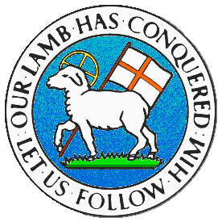
CHILDREN BROCHURE

MORAVIAN CHURCH – BARBADOS CONFERENCE
Provincial Theme: Advance the Kingdom: S.H.I.F.T.

S. – Seek & Submit
H. – Hear & Heed
I. – Imagine & Insight
F. – Focus & Function
T. – Totally Transformed

Age: 8 – 12 yrs.
S.H.I.F.T.
October 3

Scripture:

Romans 12:9 “Love must be honest and true. Hate what is evil. Hold on to what is good.” (NIRV)

Message:

There are many experiences in life which would make it richer and more enjoyable. One of which is when we love persons, we must do so with honesty and integrity. Not love them because of what they can give to us, but because of what they mean to us. Persons may give us a lot but we need to decide if they are giving out of love or because they want something from us in return. We must try to love at all times especially with the love of the Lord. Another factor we must bear in mind is that evil is real and it can trap us into doing wrong and living in a manner which is not pleasing to God.

Let us not get involved in the evils of this world, but keep away from them and not be tempted to get entangled no matter how beautiful it may appear. Another point is to cling or to hold on to what is good. There are many “bad” which may look good, but be careful and always ask Jesus Christ to help you make the right choice. He is the best of the “good” that you must cling to because He is good and wants what is good for us. True love always prevails. There is no good which will come out of being involved in evil. Cling to who and what is good.

Activity:

Can you tell the difference? Place the words in the list in the correct column.

Envy Jealously Love Compassion
Hatred Kindness Jesus Patience
Sharing Gratitude Happiness Anger
Peace Joy Caring Goodness

Hold On To These | Stay Away From These

(Answers from last week)

- The Gospel of Christ
- Truthfulness
- Being Kind-Hearted
- Wise Friends
- Being Humble
- Gentleness
- Good parents
- Being Thankful
- Exercising Self-Control
- Being Peaceful
- Faithfulness
- Being a Good Example

