**SHARONMORAVIANCHURCH**

***(Built by Slaves - 1799)***

**Sharon, St. Thomas. BB22136**

**Email:** [**sharonmoravian@caribsurf.com**](mailto:sharonmoravian@caribsurf.com)

**Church Office/Pastor’s Study Tel: 425-4011**

**Church Vestry Tel: 425-0164**



j0248997

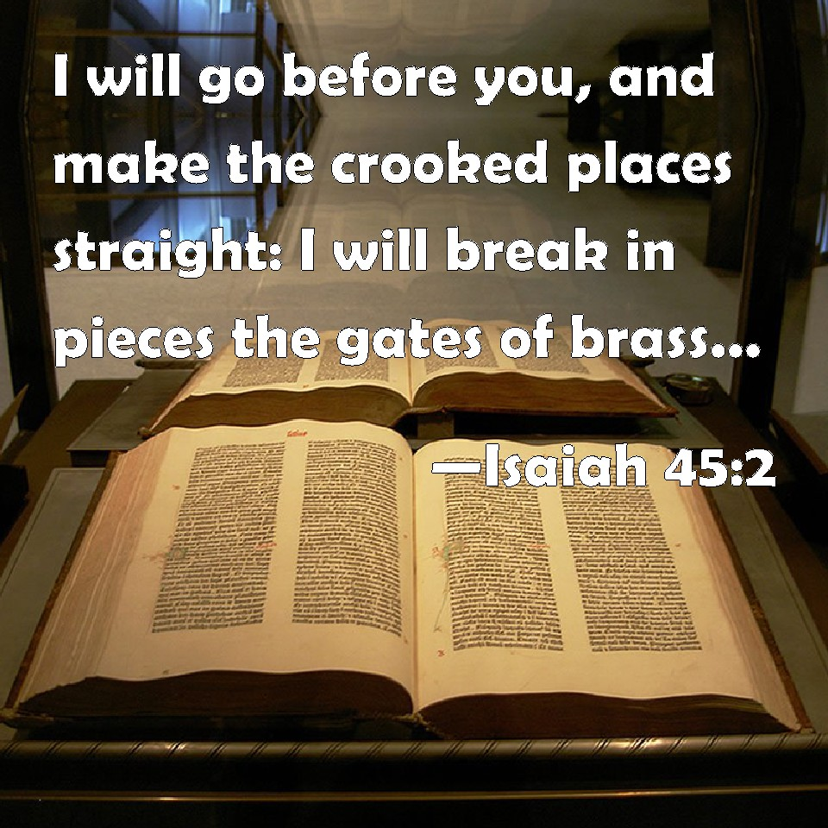

**Sunday, October 18, 2020**

**Twentieth Sunday after Pentecost**

***Women’s Fellowship Sunday***

**9:30 a.m.**

***Welcome:*We extend a cordial welcome to all, especially our Women’s Fellowship as they lead us on this Women’s Fellowship Sunday in the Barbados Conference. A warm welcome as well to those who join in worship by way of our livestream on YouTube and FaceBook.*In His presence there is fullness of joy*. Welcome.**

***Pastor: Rev. Ezra Parris***

***(Manse: 246-546-0344)***

###### Associate Pastor:

###### Rev. MovelleKellman

**WATCHWORD: Sing to the Lord, bless his name; tell of his salvation from day to day. *(Psalm 96: 2)***

**Provincial Theme 2020**: **“*Advance the Kingdom: S.H.I.F.T.*”**

**ORDER OF SERVICE**

**Organ Prelude**

**Call to Worship (Psalm 96:2):**

**Leader: Sing unto the Lord, bless His name**

**Congregation: *Show Forth His salvation from day to day***

**Hymn 484 – *“My God How Wonderful Thou Art” (453)***

**Responsive Reading: Psalm 99**

**Prayer – *Sis Lucine Baker***

**Welcome & Celebrations**

**Blessing of Tithes & Offerings**

**Adoration In Songs & Choruses**

**Ministry of the Word**

**First Scripture Reading: Isaiah 45: 1 – 7 – *Sister Yvonne Burrell***

**Second Scripture Reading: 1 Thessalonians 1: 1 – 10 – *Sister Sheila Clarke***

**Hymn of Preparation: 218 – *“Like the Woman at the Well”***

**Sermon––*Sister Lelia Gibbs***

**Prayer of Commitment & Intercession**

**Hymn 329 – *“Oh For A Closer Walk With God” (304)***

**Notices & Concerns**

**Hymn 148 – *“Light of the Lonely Pilgrim’s Heart” (134)***

**The Benediction**

**Organ Postlude**



**Visit our Website at** [**http://sharonmoravian.info**](http://sharonmoravian.info)**; Visit our Facebook Page and subscribe to our YouTube Channel. These are means by which we can connect to our brothers and sisters, and get the word out on what’s happening in the church. Like us; Follow us; Re-post us.**

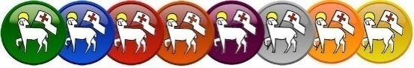

**484**

**My God how wonderful thou art,**

**Thy majesty how bright,**

**How beautiful thy mercy-seat,**

**In depths of burning light!**

**How dread are thine eternal years,**

**O everlasting Lord,**

**By prostrate spirits day and night**

**Incessantly adored!**

**O how I fear thee, living God,**

**With deepest, tenderest fears,**

**And worship thee with trembling hope**

**And penitential tears!**

**Yet I may love thee too, O Lord,**

**Almighty as thou art,**

**For thou hast stooped to ask of me**

**The love of my poor heart.**

**No earthly father loves like thee;**

**No mother, e’er so mild,**

**Bears and forbears as thou hast done**

**With me, thy sinful child.**

**How wonderful, how beautiful,**

**The sight of thee must be,**

**Thine endless wisdom, boundless power,**

**And awful purity!**

Holy Days

**Responsive Reading – Psalm 99**

**1. The Lord reigneth; let the people tremble: he sitteth between the cherubims; let the earth be moved.**

**2. The Lord is great in Zion; and he is high above all the people.**

**3. Let them praise thy great and terrible name; for it is holy.**

**4. The king’s strength also loveth judgment; thou dost establish equity, thou executest judgment and righteousness in Jacob.**

**5. Exalt ye the Lord our God, and worship at his footstool; for he is holy.**

**6. Moses and Aaron among his priests, and Samuel among them that call upon his name; they called upon the Lord, and he answered them.**

**7. He spake unto them in the cloudy pillar: they kept his testimonies, and the ordinance that he gave them.**

**8. Thou answeredst them, O Lord our God: thou wast a God that forgavest them, though thou tookest vengeance of their inventions.**

**9. Exalt the Lord our God, and worship at his holy hill; for the Lord our God is holy.**

Holy Days

**Prayer – *Sis Lucine Baker***

Holy Days

**Welcome& Celebrations:**

**We extend a cordial welcome to all, especially our Women’s Fellowship as they lead us on this Women’s Fellowship Sunday in the Barbados Conference. A warm welcome as well to those who join in worship by way of our livestream on YouTube and FaceBook.*In His presence there is fullness of joy*. Welcome.**

Holy Days

****

***Advanced: Kenrick Hinkson, Asha Jones & Justina Lowe (19th), Andrew Lowe, Barbara Maynard & Aaron Nicholls (20th), Karen Alleyne, Archibald Brathwaithe& Eula Gibbs (21st), Caroline Kellman (24th)***



***Flowers today are donated by Sis. Orrin Williams & Sis. Hilda Williams in celebration of their birthdays.***

Holy Days

**Blessing of Tithes & Offerings**

Holy Days

**Adoration In Songs & Choruses**

Holy Days

**Ministry of the Word**

**First Scripture Reading: Isaiah 45: 1 – 7 – *Sister Yvonne Burrell***

**1 Thus saith the LORD to his anointed, to Cyrus, whose right hand I have holden, to subdue nations before him; and I will loose the loins of kings, to open before him the two leaved gates; and the gates shall not be shut;**

**2 I will go before thee, and make the crooked places straight: I will break in pieces the gates of brass, and cut in sunder the bars of iron:**

**3 And I will give thee the treasures of darkness, and hidden riches of secret places, that thou mayest know that I, the LORD, which call thee by thy name, am the God of Israel.**

**4 For Jacob my servant's sake, and Israel mine elect, I have even called thee by thy name: I have surnamed thee, though thou hast not known me.**

**5 I am the LORD, and there is none else, there is no God beside me: I girded thee, though thou hast not known me:**

**6 That they may know from the rising of the sun, and from the west, that there is none beside me. I am the LORD, and there is none else.**

**7 I form the light, and create darkness: I make peace, and create evil: I the LORD do all these things.**

Holy Days

**Second Scripture Reading: 1 Thessalonians 1: 1 – 10 – *Sister Sheila Clarke***

**1. Paul, and Silvanus, and Timotheus, unto the church of the Thessalonians which is in God the Father and in the Lord Jesus Christ: Grace be unto you, and peace, from God our Father, and the Lord Jesus Christ.**

**2. We give thanks to God always for you all, making mention of you in our prayers;**

**3. Remembering without ceasing your work of faith, and labour of love, and patience of hope in our Lord Jesus Christ, in the sight of God and our Father;**

**4. Knowing, brethren beloved, your election of God.**

**5. For our gospel came not unto you in word only, but also in power, and in the Holy Ghost, and in much assurance; as ye know what manner of men we were among you for your sake.**

**6. And ye became followers of us, and of the Lord, having received the word in much affliction, with joy of the Holy Ghost.**

**7. So that ye were ensamples to all that believe in Macedonia and Achaia.**

**8. For from you sounded out the word of the Lord not only in Macedonia and Achaia, but also in every place your faith to God-ward is spread abroad; so that we need not to speak any thing.**

**9. For they themselves shew of us what manner of entering in we had unto you, and how ye turned to God from idols to serve the living and true God;**

**10. And to wait for his Son from heaven, whom he raised from the dead, even Jesus, which delivered us from the wrath to come.**

Holy Days

**Hymn of Preparation: 218 –**

**Like the woman at the well, I was seeking**

**For things that could not satisfy;**

**And then I heard my Saviour speaking;**

**“Draw from my well that shall never run dry.”**

***Fill my cup Lord, I lift it up Lord!***

***Come and quench this thirsting of my soul;***

***Bread of heaven, feed me till I want no more –***

***Fill my cup, fill it up and make me whole!***

**There are millions in this world who are craving,**

**The pleasures earthly things afford;**

**But none can match the wondrous treasure**

**That I find in Jesus Christ, my Lord.**

**So, my brother, if the things this world gave you,**

**Leave hungers that won’t pass away,**

**My blessèd Lord will come and save you**

**If you kneel to Him and humbly pray.**

Holy Days

**Sermon––*Sister Lelia Gibbs***

Holy Days

**Prayer of Commitment & Intercession**

Holy Days

**Hymn 329–**

**O for a closer walk with God,**

**A calm and heavenly frame;**

**A light to shine upon the road**

**That leads me to the Lamb!**

**Where is the blessedness I knew,**

**When first I saw the Lord?**

**Where is the soul-refreshing view**

**Of Jesus and his word?**

**What peaceful hours I once enjoyed,**

**How sweet their memory still;**

**But they have left an aching void**

**The world can never fill.**

**Return, O holy Dove, return,**

**Dear messenger of rest;**

**I hate the sins that made thee mourn,**

**And drove thee from my breast.**

**The dearest idol I have known,**

**Whate’er that idol be,**

**Help me to tear it from thy throne,**

**And worship only thee.**

**So shall my walk be close with God,**

**Calm and serene my frame;**

**So purer light shall mark the road**

**That leads me to the Lamb.**

Holy Days

**Notices& Concerns**

**OPPORTUNITIES FOR SERVICE & INVOLVEMENT**

**Office Hours: Tuesday & Friday, 8:30 a.m. – 12:30 p.m. and 1:30 – 4:30 p.m. (D. C. Moore Centre)**

**Tuesday:**  **Women’s Fellowship–5:00 p.m.**

**Wednesday: Online Bible Study – 6:00 p.m.**

**Next Sunday: Divine Worship& Missionary Festival– 9:30 a.m.**

**Women’s Fellowship Candlelight Service at Calvary Moravian Church – 5:00 p.m.**

Holy Days

**IN THE MONTH OF OCTOBER – Women’s Fellowship Month**

* **Missionary Love Feast at Calvary – Sunday, 25th, 9:30 a.m.**
* **The Conference at Prayer – Saturday, 24th 6:00 a.m.**
* **Please bear in mind that we will soon be celebrating our Harvest Festival in November.**

Holy Days

**NEWS, INFORMATION & REMINDERS**

1. **Our Missionary Festival will be held on Sunday, October 25, 2020 at the weekly worship hour of 9:30 a.m. Funds raised will go towards the local missions, and to missionary endeavours across the region and the world through the various mission organisations of the Moravian Church.**
2. **Flower Festival 2021: As 2020 draws to a close, we look with faith to a brighter 2021 in every area of our lives. We seek a renewal physically, spiritually and morally, and we pray for a Rebirth!**

* **Hence the theme for the FLOWER FESTIVAL 2021 – REBIRTH! The Festival is scheduled for Whitsuntide Weekend 2021 – May 22 – 24.**
* **The Flower Festival Committee has met and plans are in progress. This is an invitation to ALL members and friends to once again sponsor and donate to this event. Sponsorship fees remain unchanged at $300.00. We look forward to your support as before. All persons desirous of sponsoring – again or for the first time – should indicate by the end of December, so that a location can be reserved for you.**

1. **We are thankful for the financial support we have been receiving thus far, particularly in the light of the economic impact of the COVID-19 Pandemic. We are mindful that some of you may be facing reduced or lost income due to this crisis.**

* **We are challenged however, in maintaining our ministry, our facilities and paying property insurance. So we ask for your continued faithfulness in giving as you are able.**
* **Those who attend worship in the sanctuary are reminded that offerings are deposited in the baskets on entry.**
* **Those who are not back out to church as yet are reminded that labelled envelopes can be dropped into the slot in the front door of the Manse.**
* **Generally, those who would give electronically can do so by direct deposit to our account at Scotiabank, Warrens – 40274. You can also give via SurePay at a walk-in kiosk or using your online account. At SurePay you can make payments anonymously to the Moravian Church (*Account No: 1765-1768-0000, Name: Sharon Moravian Church*), or if you need your donations recorded for tax purposes and you have a box of envelopes; make payments to the Moravian Church (*Account No: 1765-1768-0-[your 3-digit envelope number], Name: Your Name*). Visit** [**www.sharonmoravian.info/giving-monetary**](http://www.sharonmoravian.info/giving-monetary) **for these details.**

1. **Flowers are needed for our church! You will find on the Notice Board next to the main door to the church, a roster in the shape of flower. You may sign up to indicate that you would (1) cover the cost to obtain flowers for the arrangements or (2) provide the complete arrangements, for a particular Sunday(s). Feel free to join with others to provide the flowers to celebrate your birthday(s) etc.**
2. **Remember to listen to the Moravian Radio Programme: “Moravian Voice” on LIFE 97.5 FM, Wednesdays at 8:00 pm.**
3. **Remember our Basket of Hope Ministry. There are still those in our community that are in need of our assistance. You are invited each Sunday to make donations of non-perishable food items, which can be deposited in the basket placed at the rostrum (Altar).**

Holy Days

**PRAYER NEEDS:**

**Our Shut-ins:**  ***Daphne Bispham, Aileen Bowen, Royle Deane, Grace Lashley, Muriel Moore, Erla Reid, Carol St. John.***

SY01652_

**The Sick / Recovering:**  ***Sis Eula Gibbs***

Holy Days

**Closing Hymn: 148**

**Light of the lonely pilgrim’s heart,  
The star of the coming day,  
Arise, and with thy morning beams  
Chase all our griefs away.**

**Come, blessèd Lord, let every shore  
And answering island sing  
The praises of thy royal name,  
And own thee as their king.**

**Bid the whole earth, responsive now  
To that bright world above,  
Break forth in rapturous strains of joy,  
In memory of thy love.**

**Lord, Lord, thy fair creation groans,**

**The air, the earth, the sea,**

**In unison with all our hearts,**

**And calls aloud for thee.**

**Come then, with all thy quickening power,**

**With one awakening smile,**

**And bid the serpent’s trail no more**

**Thy beauteous realms defile.**

**Thine was the cross, with all its fruit  
Of grace and peace divine;  
Be thine the crown of glory now,  
The palm of victory thine.**

Holy Days

**Benediction**

Holy Days

**AVAILABLE:**

* **Offering Envelopes for 2020 – We invite each member of the congregation to receive a box of envelopes and thereby seek to faithfully support the work of the church. Please request that a box be provided for you if none has been provided as yet.**
* **Missionary Collection Boxes– If you had a box last year, please collect it from the Vestry. If you desire a box for the first time, please inquire at the vestry after worship or at the Church Office.**
* **Sharon Burgundy Shirts:   Polos – $30   /   T-Shirts – $15**
* **On order from the Church Office, copies of Sunday sermons on CD – $2.00.**
* **Greeting Cards ($2.00) and Prints ($20.00) of a painting of Sharon Church from the Church Office.**
* **Books by Rev. Neilson Waithe: Understanding the Caribbean Worker– $25.00; Provocation– $20.**
* **The Book, ‘Created in Their Image: *Evangelical Protestantism in Antigua and Barbados 1834-1914’* written by Rev. Dr. Winelle Kirton-Roberts.  The cost is $50.00.**

Holy Days

Protocol for Worship Services during the COVID-19 Pandemic – 2020

**In keeping with the directive given by the Prime Minister of Barbados:**

1. **Sanitisation stations shall be set up at the entrances and exits which shall be manned by ushers.**
2. **All attending shall sanitise their hands upon entering the church.**
3. **The names of all who attend service shall be recorded.**
4. **The temperature of each worshipper and minister shall be taken before entering the church, using a contactless thermometer;**

* **persons whose temperature exceed 37.5° C shall not be allowed to enter the church;**
* **persons who are coughing repeatedly, sneezing or exhibit any flu-like symptoms shall not be allowed to enter the church.**

1. **Face masks shall be worn throughout the service by all persons present in the church. Worship Leaders may remove their masks temporarily to fulfil their roles, provided that there is at least six feet between leaders, and between leaders and congregants.**
2. **There shall be no physical contact between attendees.**
3. **There shall be a physical distance of at least three feet between all attending except between members of the same household who may sit together; in which case, there shall be a distance of at least three feet between one group and adjacent groups or individuals.**
4. **Attendees shall be asked to deposit their offerings in fixed containers.**
5. **No hymnals, Bibles, leaflets or other materials shall be distributed to worshippers;**

* **Bibles, hymnals etc. should only be shared by family members;**
* **The Lectern Bible shall also be removed and lesson readers shall be asked to use their own Bible.**

1. **Infant Baptism, Confirmation, Dedication, laying on of hands or anointing have been suspended for the time being.**
2. **Windows and doors shall be kept open to allow for ventilation.**
3. **Attendees shall be asked to maintain the recommended social distance when leaving the building.**
4. **There shall be no congregating of worshippers inside or outside of the church, before or after service.**

Holy Days